"Harley delivers an uninhibited performance with wry sense of humor and a love of life we can all share…" Los Angeles Times
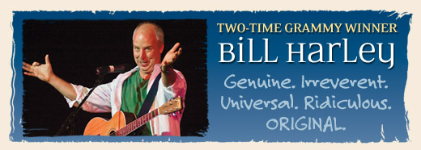
"A master musician and storyteller, Harley's enthusiasm for recounting events from his life is contagious and there is little the audience can do to guard against its joyous side-effects." Nuvo Newsweekly

BILL HARLEY
Two-time Grammy Award Winner, and acclaimed author/storyteller/ musician, will perform in ____________!
DATE, TIME:
PLACE:
TICKETS:
Information:

Bill Harley is well‐traveled, well‐read, well‐educated, well‐spoken and well‐loved. Accompanied by his guitar, his narrative songs and stories, both original and traditional, are a celebration of our common humanity. A two‐time Grammy winner, he is vibrant, outrageous, unpredictable and genuine with songs and stories about growing up, schooling and what it is to be human — our connections with one another and with the planet we share. Recognized by audiences and peers as one of the finest performing storytellers in the country, his work has influenced a generation of children, parents, performing artists and educators. Bill's newest recording for adults, Same Moon was recorded during a live show in his barn. Bill tours internationally as a performing artist, author and keynote speaker from his home in Seekonk, Massachusetts.

PRESS CONTACT: Debbie Block, (508) 336-9703, debbie@billharley.com
PRESS INFO and PICTURES: http://www.billharley.com/in-person/for-the-press

