“He combines wry observation with well-crafted folk, pop and rock music to tell tales that tickle the funny bone and tease the brain.” – Boston Globe

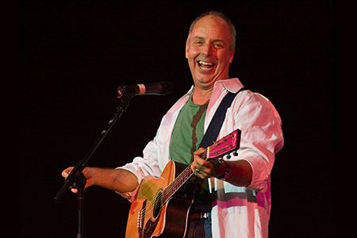

“Harley delivers an uninhibited performance with wry sense of humor and has a love of life we can all share…"
-- Los Angeles Times

BILL HARLEY
2-time Grammy Award Winner and acclaimed storyteller/musician will perform in Your Town!

Date, Time
Place
Address
Phone and/or Website
Information and Tickets

Recognized by audiences and peers as one of the finest performing storytellers in the country, Bill Harley's work has influenced a generation of children, parents, performing artists and educators. Best known for his work with children and families, his ability to navigate through a confusing world with humor and wisdom is evident in his masterful storytelling as well as his numerous award‐winning recordings and books. Bill tours internationally as a performing artist, author and keynote speaker from his home in Seekonk, Massachusetts. His latest book series is about the trials and tribulations of 4th grader Charlie Bumpers. Winner of numerous awards including The Beverly Cleary Children’s Choice Award, it is also a One School, One Book pick for schools nationwide. For more about Bill’s work please visit: www.billharley.com.
PRESS INFO and PICTURES: http://www.billharley.com/in-person/for-the-press

